Alice is texting Bob using her phone. The **mapping** of digits to letters is shown in the figure below.

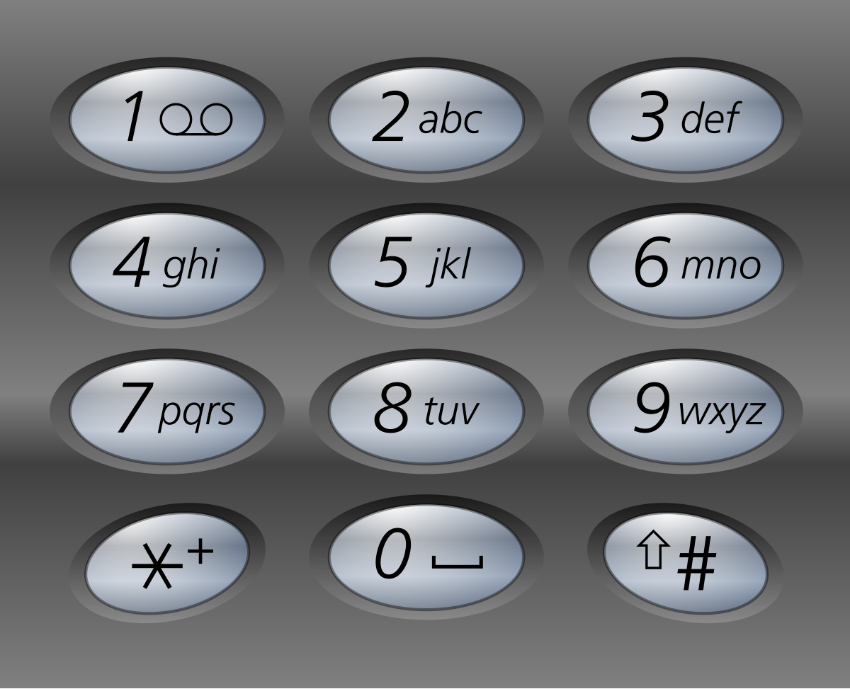

In order to **add** a letter, Alice has to **press** the key of the corresponding digit i times, where i is the position of the letter in the key.

* For example, to add the letter 's', Alice has to press '7' four times. Similarly, to add the letter 'k', Alice has to press '5' twice.
* Note that the digits '0' and '1' do not map to any letters, so Alice **does not** use them.

However, due to an error in transmission, Bob did not receive Alice's text message but received a **string of pressed keys** instead.

* For example, when Alice sent the message "bob", Bob received the string "2266622".

Given a string pressedKeys representing the string received by Bob, return *the****total number of possible text messages****Alice could have sent*.

Since the answer may be very large, return it **modulo** 109 + 7.

**Example 1:**

**Input:** pressedKeys = "22233"

**Output:** 8

**Explanation:**

The possible text messages Alice could have sent are:

"aaadd", "abdd", "badd", "cdd", "aaae", "abe", "bae", and "ce".

Since there are 8 possible messages, we return 8.

**Example 2:**

**Input:** pressedKeys = "222222222222222222222222222222222222"

**Output:** 82876089

**Explanation:**

There are 2082876103 possible text messages Alice could have sent.

Since we need to return the answer modulo 109 + 7, we return 2082876103 % (109 + 7) = 82876089.

**Constraints:**

* 1 <= pressedKeys.length <= 105
* pressedKeys only consists of digits from '2' - '9'.